
MINISTRY OF EDUCATION AND TRAINING
FPT UNIVERSITY

SAP341 Project Document

WAREHOUSE MANAGEMENT SYSTEM
FOR DRY GOODS & CEREALS (WM_Software)
Item | Information
Group Name | <Group Name>
Group Members | <Member name> – <RollNo> – <Student code>  <Member name> – <RollNo> – <Student code>  <Member name> – <RollNo> – <Student code>  <Member name> – <RollNo> – <Student code>
Lecturer | <Lecturer name>

- Hanoi, July 2026 -

Table of Contents
Acknowledgement........................................................................................................... 4
Definition and Acronyms................................................................................................ 4
I. Project Introduction.................................................................................................... 5
1. Overview................................................................................................................. 5
1.1 Project Information........................................................................................... 5
1.2 Project Team...................................................................................................... 5
2. Product Background................................................................................................ 5
3. Existing Solutions.................................................................................................... 5
4. Project Scope & Limitations.................................................................................... 6
II. Software Requirement Specification.......................................................................... 8
1. Requirement Overview............................................................................................ 8
2. Functional Specifications......................................................................................... 8
2.1 Authentication & Account Management............................................................ 8
2.2 Master Data Management.................................................................................. 9
2.3 Warehouse Operations – Documents................................................................ 10
2.4 Batch Management & Traceability.................................................................. 13
2.5 Alerts, Dashboard & Reports........................................................................... 13
2.6 Audit Log......................................................................................................... 13
3. Non-Functional Requirements............................................................................... 13
3.1 External Interfaces........................................................................................... 13
3.2 Quality Attributes............................................................................................ 14
4. Requirement Appendix.......................................................................................... 14
4.1 Business Rules.................................................................................................. 14
4.2 Common Requirements.................................................................................... 15
4.3 Application Messages List................................................................................ 15
III. Software Design Description................................................................................... 16
1. System Design........................................................................................................ 16
1.1 System Architecture......................................................................................... 16
1.2 Package Diagram............................................................................................. 16
2. Database Design..................................................................................................... 16
IV. Software Testing Documentation............................................................................. 20
1. Scope of Testing..................................................................................................... 20
1.1 Target of test – features and functions.............................................................. 20
1.2 Non-functional requirements in scope.............................................................. 20
1.3 Test stages / levels applied................................................................................ 20
1.4 Constraints and assumptions............................................................................ 21
2. Test Strategy.......................................................................................................... 21
2.1 Testing Types................................................................................................... 21
2.2 Test Levels....................................................................................................... 22
2.3 Supporting Tools.............................................................................................. 23
3. Test Cases.............................................................................................................. 23
3.1 Unit test cases (sample)..................................................................................... 23
3.2 System-level test cases (sample)........................................................................ 24
4. Test Reports........................................................................................................... 25
4.1 Result statistics................................................................................................. 25
4.2 Defect summary............................................................................................... 25
4.3 Analysis and conclusion.................................................................................... 25

Acknowledgement
We would like to express our sincere gratitude to our lecturer of the SAP341 course at FPT University for the continuous guidance, constructive feedback, and encouragement throughout the development of this project. We also thank our teammates for their dedication and collaboration during requirement analysis, implementation, and testing, as well as our classmates who participated in trial sessions and provided valuable suggestions that helped us improve the usability of the application.

Definition and Acronyms
Acronym | Definition
WMS | Warehouse Management System
FEFO | First Expired, First Out – dispatching principle that prioritizes batches with the nearest expiry date
BR | Business Rule
UC | Use Case
UI | User Interface
SRS | Software Requirement Specification
SDD | Software Design Description
NFR | Non-Functional Requirement
CRUD | Create, Read, Update, Delete
MVC | Model – View – Controller architectural pattern
HSD | Hạn sử dụng (expiry date)
NCC | Nhà cung cấp (supplier)
M3 | Material Design 3 (Google design system)
UAT | User Acceptance Test
QR | Quick Response code

I. Project Introduction

1. Overview
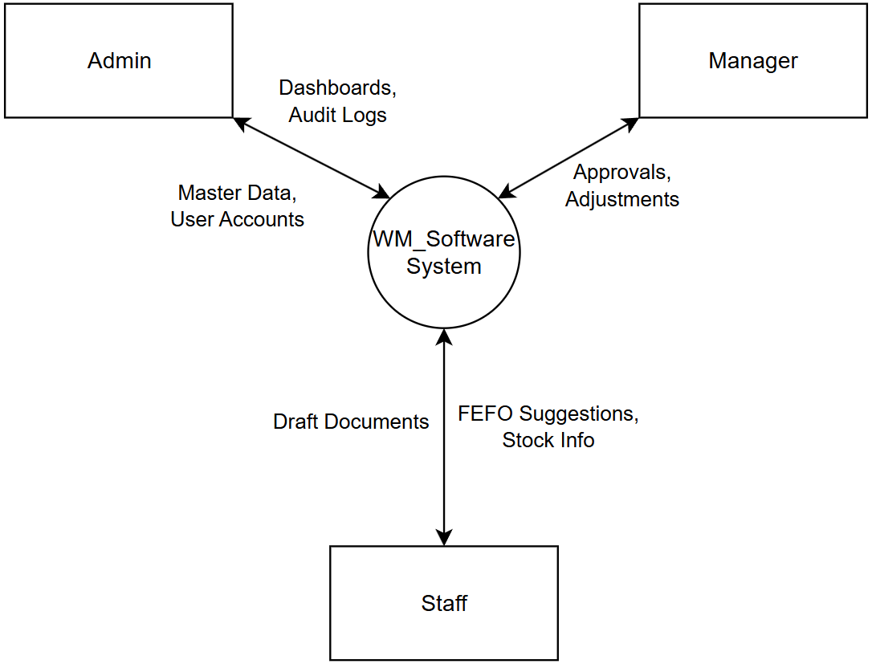

1.1 Project Information
Item | Detail
Project name | Warehouse Management System for Dry Goods & Cereals
Project code | WM_Software
Repository | github.com/kimky-hd/WM_Software
Platform | Cross-platform mobile application built with Flutter (Android / iOS; also buildable for web and desktop)
Group name | <Group Name>
Course | SAP341 – FPT University
Version | 1.0 – July 2026

1.2 Project Team
No. | Member | Task / Screen
1 | <Member name A> | Authentication (Login), Account management, Product background, Test plan
2 | <Member name B> | Master data screens (Product, Unit, Supplier), Business rules
3 | <Member name C> | Inbound / Outbound notes, FEFO suggestion logic, State management
4 | <Member name D> | Stock check, Adjustment, Return-to-supplier, Damage/expired notes
5 | <Member name E> | Manager approval screens, Dashboard, Reports, Audit log

2. Product Background
Small and medium warehouses of dry goods and cereals in Vietnam (rice, beans, nuts, oats, dried food, etc.) commonly manage their inventory on paper or with simple spreadsheets. This category of goods is particularly sensitive because every batch has a limited shelf life and quantities naturally shrink over time due to moisture loss, pests, or breakage during handling.
Manual management leads to several recurring problems: goods expire on the shelf because nobody tracks which batch should be dispatched first; the recorded stock quantity differs from the physical count; there is no approval trail, so mistakes and losses cannot be traced back to a responsible person; and warehouse owners have no timely warning when stock runs low or when a batch is about to expire.
From this situation, the team proposed building a lightweight mobile Warehouse Management System dedicated to a single-warehouse model with three user roles (Admin, Warehouse Manager, Warehouse Staff). The system digitalizes the six core warehouse documents (inbound, outbound, stock check, adjustment, return-to-supplier, damage/expired), enforces an approval workflow, tracks stock at batch level, applies the FEFO dispatching principle, and raises automatic alerts for low stock and near-expiry batches.

3. Existing Solutions
Before designing the system, the team surveyed several existing products that address inventory management in the Vietnamese market and worldwide:
Solution | Strengths | Gaps for our target users
KiotViet / Sapo | Popular Vietnamese retail platforms; POS, sales and simple stock tracking | Retail/POS-centric; batch & expiry tracking and FEFO are limited or locked behind higher plans; approval workflow for warehouse documents is not the focus
MISA eShop / MISA SME | Strong accounting integration, invoices, reports | Oriented to accounting; heavy for a small single warehouse; mobile warehouse operations are secondary
Odoo Inventory | Full-featured open-source WMS: lots/serials, FEFO removal strategy, multi-warehouse | Complex to deploy and configure; requires a server; overkill for a one-warehouse operation with 3 roles
SAP Business One | Enterprise-grade batch management and traceability | High cost and implementation effort; not suitable for small businesses
These solutions confirm that batch management and FEFO are industry-standard requirements, but none of them offers a simple, mobile-first, low-cost tool tailored to a single dry-goods warehouse with a strict create–approve workflow. This gap is the motivation for WM_Software.

4. Project Scope & Limitations

In scope
• Single-warehouse model with three hierarchical roles: Admin, Warehouse Manager, Warehouse Staff, controlled by a detailed permission matrix.
• Authentication: login/logout, session restore, change password; Admin creates and locks/unlocks accounts for the two operational roles.
• Shared master data: product catalog (code, name, category, base unit, minimum stock, default shelf life), units of measure with conversion factors (e.g. 1 bag = 25 kg, 1 ton = 1,000 kg), and suppliers.
• Six warehouse document types created by Staff and approved by the Manager: Inbound, Outbound, Stock check, Stock adjustment, Return-to-supplier, and Damage/expired notes, all following the common status flow Draft → Pending approval → Approved → Completed (or Rejected / Cancelled).
• Batch (lot) management: each approved inbound line creates a batch with manufacture date, expiry date and remaining quantity; outbound suggestions follow FEFO; batch traceability.
• Automatic alerts: low stock (below minimum), near-expiry (configurable X days), and expired batches.
• Dashboard and reports: overview KPIs, inbound–outbound–stock reports, stock by batch, damage/shrinkage summary.
• Audit log recording who created/approved/rejected/cancelled which document and when; approved data is locked against editing by Staff.

Limitations
• Data is persisted locally on the device using SharedPreferences (as a temporary storage layer); there is no server backend yet, so data is not shared between devices in version 1.0.
• The QR/Barcode scanning screen is provided at UI level; integration with a real camera scanning library is planned for a later version.
• Export of reports to Excel/PDF and push notifications are defined as optional advanced features and are not implemented in version 1.0.
• Password recovery by email requires a backend mail service and is therefore simulated in this version.

II. Software Requirement Specification

1. Requirement Overview
The system serves three actors in a single-warehouse model. Warehouse Staff performs the physical operations and creates documents; the Warehouse Manager runs the warehouse and approves every document; the Admin administers the system (accounts, master data) without taking part in daily operations.
# | Feature group | Main functions | Actors
F1 | Authentication & Accounts | Login/Logout, session restore, change password, account management (create, lock/unlock) | All roles / Admin
F2 | Master data | Product catalog, units of measure & conversion, suppliers | Admin (full), Manager, Staff (view)
F3 | Warehouse documents | Inbound, Outbound (FEFO), Stock check, Adjustment, Return-to-supplier, Damage/expired – create & approve workflow | Staff (create), Manager (approve)
F4 | Batch management | Batch created on inbound approval, FEFO suggestion, batch traceability | Staff, Manager
F5 | Alerts & Dashboard | Low-stock / near-expiry / expired alerts, overview dashboard, reports | Manager, Admin
F6 | Control | Audit log, data locked after approval, cancel with reason | Manager, Admin

2. Functional Specifications
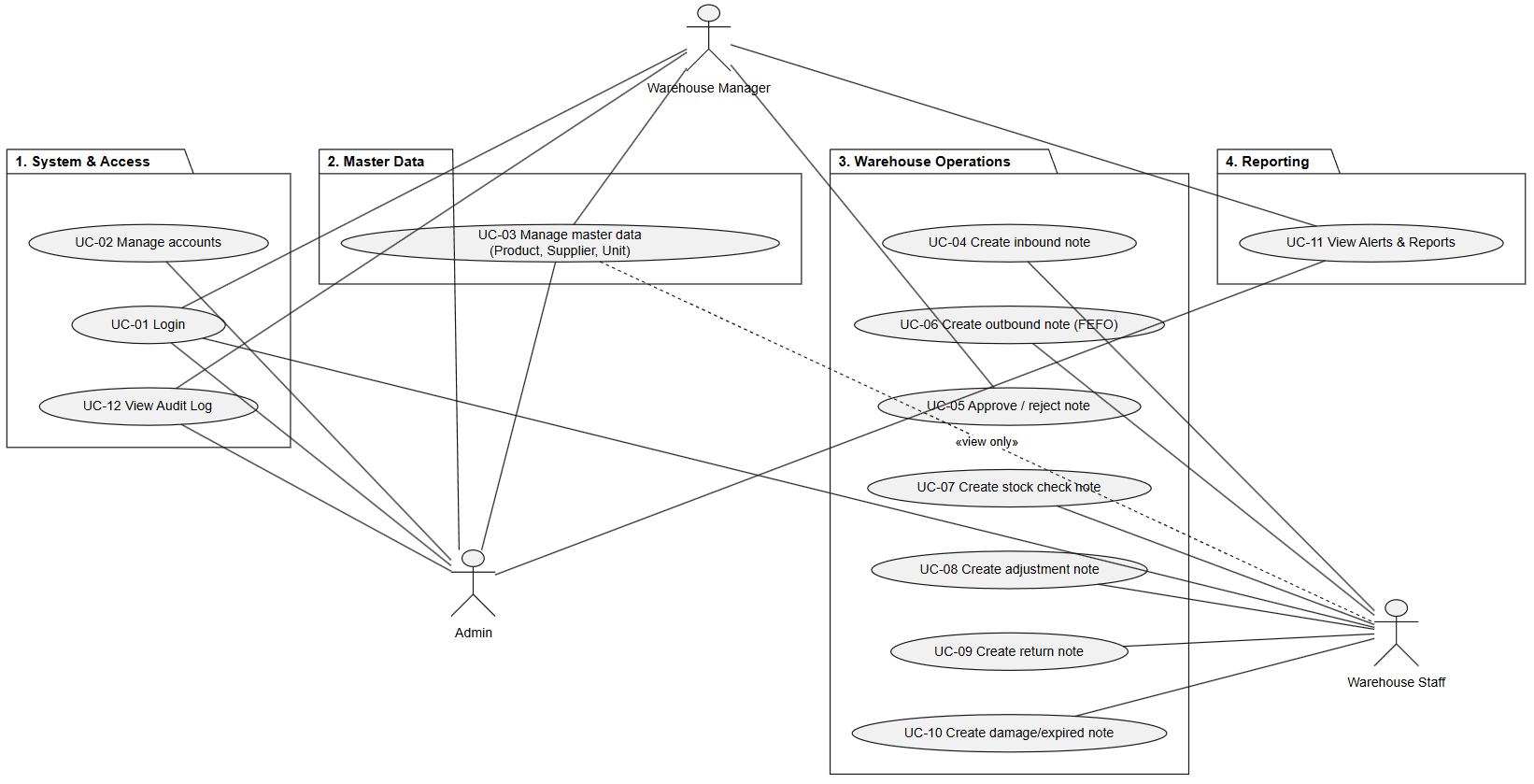

2.1 Authentication & Account Management

2.1.1 Login screen
The entry screen of the application. The user signs in with email and password; the system validates credentials against the stored user list, restores the session on the next launch, and routes the user to the home screen matching his/her role (Staff home, Manager home, or Admin dashboard).
[Insert mockup / screenshot of the screen here]
Main UI components:
• Email input field (validated as required, email format)
• Password input field (obscured, required)
• Login button with loading state
• Error message shown when credentials are wrong or the account is locked

Use case | UC-01 Login
Actors | Admin, Warehouse Manager, Warehouse Staff
Precondition | The account exists and is active
Main flow | 1. User opens the app and the Login screen is displayed.  2. User enters email and password, then taps Login.  3. System validates the input fields.  4. System verifies credentials and role.  5. System saves the session and navigates to the role-specific home screen.
Alternative flow | 3a. A field is empty/invalid → an inline validation message is shown.  4a. Credentials are wrong or the account is locked → an error message is shown and the user stays on the Login screen.
Postcondition | The user session is stored locally and restored automatically on the next app launch until logout.

2.1.2 User management (Admin)
The Admin creates accounts for Warehouse Managers and Warehouse Staff, edits their information, and locks/unlocks accounts. A locked account cannot sign in.
[Insert mockup / screenshot of the screen here]
Main UI components:
• List of users with name, email, role and status badge
• Create/edit form: full name, email, password, role
• Lock / unlock toggle with confirmation dialog

Use case | UC-02 Manage accounts
Actors | Admin
Precondition | Admin is logged in
Main flow | 1. Admin opens User management.  2. Admin creates a new account or selects an existing one.  3. Admin saves changes; the list refreshes.  4. Admin can lock/unlock the account.
Alternative flow | 2a. Email already exists → error message, the account is not created.
Postcondition | Account list is updated; a locked user can no longer log in.

2.1.3 Change password
Every role can change the account password after providing the current password. Forgotten-password recovery is defined for a later version because it requires a mail backend.
[Insert mockup / screenshot of the screen here]
Main UI components:
• Current password, new password and confirmation fields
• Validation: minimum length, confirmation must match

2.2 Master Data Management

2.2.1 Product catalog
Maintains the list of goods handled by the warehouse. Each product stores a unique code, name, category (cereals/nuts/dried goods…), base unit, minimum stock level and a default shelf life in days used to pre-fill the expiry date on inbound lines. Admin has full CRUD rights; Manager and Staff can view.
[Insert mockup / screenshot of the screen here]
Main UI components:
• Searchable product list with category chips and stock information
• Create/edit form: code, name, category, base unit, minimum stock, default expiry (days)

Use case | UC-03 Manage product catalog
Actors | Admin (full), Manager/Staff (view)
Precondition | User is logged in
Main flow | 1. User opens the Product catalog.  2. Admin adds or edits a product and saves.  3. The catalog list is refreshed and available in all document forms.
Alternative flow | 2a. Product code is duplicated or a numeric field is invalid → validation message is shown.
Postcondition | The product is available for selection on inbound/outbound and other documents.

2.2.2 Units of measure & conversion
Defines measurement units together with the conversion factor to the base unit, e.g. kg (factor 1), bag = 25 kg, ton = 1,000 kg, pack = 0.5 kg. Documents may be entered in any unit; the system converts quantities to the base unit for stock calculation.
[Insert mockup / screenshot of the screen here]
Main UI components:
• Unit list with conversion factor to the base unit
• Create/edit form: unit name, conversion factor

2.2.3 Supplier management
Maintains supplier records: name, contact, tax code. Suppliers are referenced by inbound notes and return-to-supplier notes, providing a transaction history per supplier.
[Insert mockup / screenshot of the screen here]
Main UI components:
• Supplier list with contact and tax code
• Create/edit supplier form

2.3 Warehouse Operations – Documents
All six document types share a common approval workflow: the Warehouse Staff creates a note (status Pending approval); the Warehouse Manager reviews and either approves or rejects it with a reason. Approval is the only event that changes stock. After approval, Staff cannot edit or delete the note; only the Manager may cancel it, and the cancellation is written to the audit log.

2.3.1 Inbound note (Phiếu nhập kho)
Records goods received from a supplier. Each line selects a product, quantity, unit, manufacture date and expiry date; when the Manager approves the note, every line generates a new batch and the stock quantity increases accordingly.
[Insert mockup / screenshot of the screen here]
Main UI components:
• Supplier picker (required)
• Dynamic line items: product, quantity (> 0), unit, manufacture date, expiry date (auto-suggested from the product's default shelf life)
• Submit button – the note is sent for approval
• List screen with status chips (Pending, Approved, Rejected…)

Use case | UC-04 Create inbound note
Actors | Warehouse Staff
Precondition | Staff is logged in; products, units and suppliers exist
Main flow | 1. Staff opens Create inbound note.  2. Staff selects the supplier and adds one or more product lines with quantity, unit, manufacture date and expiry date.  3. Staff submits; the note gets a generated code and status Pending approval.  4. The note appears in the Manager's approval queue.
Alternative flow | 2a. No line is added → message 'Cần ít nhất 1 dòng sản phẩm'.  2b. A required field is missing or quantity ≤ 0 → inline validation message.
Postcondition | The inbound note is stored with status Pending approval; stock is NOT yet changed.

Use case | UC-05 Approve / reject inbound note
Actors | Warehouse Manager
Precondition | An inbound note is Pending approval
Main flow | 1. Manager opens the inbound approval list and selects a note.  2. Manager reviews supplier and line details.  3. Manager approves: the system creates one new batch per line (code, manufacture/expiry date, quantity), adds the quantity to stock, sets the status to Approved and writes an audit-log entry.
Alternative flow | 3a. Manager rejects: a reason is required; the note returns to the Staff with status Rejected and no stock change.
Postcondition | On approval: batches exist, stock increased, audit log recorded, note locked for Staff.

2.3.2 Outbound note (Phiếu xuất kho – FEFO)
Records goods dispatched from the warehouse for a stated purpose. When Staff enters a product and a required quantity, the system automatically proposes an allocation across batches ordered by nearest expiry date (FEFO). Staff may override the proposed batches, in which case the reason is logged. Quantity per batch is validated against the batch's remaining stock. On approval, the remaining quantity of each batch is reduced; if total stock falls below the product's minimum, a low-stock alert is raised.
[Insert mockup / screenshot of the screen here]
Main UI components:
• Purpose text field
• Line items: product, required quantity, unit
• FEFO suggestion panel listing proposed batches (batch code, expiry date, allocated quantity)
• Inline validation: allocated quantity must not exceed the batch's remaining quantity

Use case | UC-06 Create outbound note with FEFO suggestion
Actors | Warehouse Staff
Precondition | Stock exists for the requested products
Main flow | 1. Staff opens Create outbound note and enters the purpose.  2. Staff adds a product and required quantity.  3. The system proposes batch allocations following FEFO (nearest expiry first) until the quantity is covered.  4. Staff confirms (or adjusts) the batch allocation and submits.  5. The note is stored as Pending approval.
Alternative flow | 3a. Total remaining stock is insufficient → the shortage is reported and the note cannot be submitted for the missing amount.  4a. Staff picks a different batch than suggested → the change and reason are logged.  4b. An allocated quantity exceeds the batch remaining → inline validation error.
Postcondition | On Manager approval, batch remaining quantities and total stock are reduced; a low-stock alert is created if stock drops below the minimum level.

2.3.3 Stock check note (Phiếu kiểm kê)
Supports periodic physical counting. Staff records the counted quantity per product; the system displays the system quantity and computes the variance. The Manager approves the counting result, which then serves as the basis for adjustment notes.
[Insert mockup / screenshot of the screen here]
Main UI components:
• Line per product: system quantity (read-only), actual counted quantity, computed variance
• Approval screen for the Manager showing all variances

2.3.4 Stock adjustment note (Phiếu điều chỉnh tồn)
Staff proposes an inventory adjustment (increase or decrease) with a mandatory reason such as shrinkage or stock-check variance; the Manager approves and the stock is corrected accordingly.
[Insert mockup / screenshot of the screen here]
Main UI components:
• Product/batch selector, adjustment quantity, reason (required)

2.3.5 Return-to-supplier note (Phiếu trả hàng NCC)
Used when received goods are defective or fail quality checks. The note references the supplier and the affected batch and quantity; on approval the quantity is removed from stock.
[Insert mockup / screenshot of the screen here]
Main UI components:
• Supplier and batch pickers, quantity, reason

2.3.6 Damage / expired note (Phiếu hàng hỏng / hết hạn)
Removes damaged or expired goods from stock without counting them as sales. The note records the batch, quantity, type (damaged or expired) and reason; approved notes feed the damage/shrinkage report.
[Insert mockup / screenshot of the screen here]
Main UI components:
• Batch picker, quantity, type (Damaged / Expired), reason

2.4 Batch Management & Traceability
Batch management is the core differentiator for a dry-goods warehouse. A batch is created automatically for every approved inbound line and stores: batch code, product, manufacture date, expiry date, quantity received and quantity remaining, plus a reference to the source inbound note. The batch list can be filtered per product to trace when a batch was received, how much has been dispatched, and how much remains. Batches drive the FEFO suggestion on outbound notes and the near-expiry/expired alerts.

2.5 Alerts, Dashboard & Reports
• Low stock alert: total remaining quantity of a product < its minimum stock level – visible to Manager and Admin.
• Near-expiry alert: a batch's expiry date is within X days (configurable) – visible to Manager and Admin.
• Expired alert: a batch has passed its expiry date but has not been processed by a damage/expired note.
• Dashboard: Admin dashboard shows total products, total suppliers, total accounts, and current alert counters. Manager dashboard shows total stock and number of documents pending approval...
• Reports: inbound–outbound–stock by period and product; stock by batch with remaining shelf life; damage/shrinkage summary by period and cause. Excel/PDF export is an optional future feature.

2.6 Audit Log
Every approval, rejection and cancellation of documents, as well as master data and account modifications (create, update, delete, lock) performed by the Admin, are written to an immutable audit log...

3. Non-Functional Requirements

3.1 External Interfaces
• User interface: Flutter Material Design 3 components with a light warm theme (amber seed color), rounded cards and outlined input fields; UI text is presented in Vietnamese for end users.
• Hardware interface: standard Android/iOS smartphones; the QR/Barcode screen is prepared for integration with the device camera.
• Software interface: local persistence through the SharedPreferences API (JSON-serialized models). The data layer is isolated behind a storage class so that it can be replaced by a REST backend without touching the UI.

3.2 Quality Attributes
Attribute | Requirement
Usability | A new staff member can create an inbound note without training in under 3 minutes; all validation messages are specific and shown inline in Vietnamese.
Performance | Screen navigation and list rendering complete within 1 second for up to 1,000 documents on a mid-range device; app cold start under 3 seconds.
Reliability | Stock quantities are changed only by the approval event; approved documents are locked; data is persisted immediately after every mutation.
Security | Role-based access control according to the permission matrix; locked accounts cannot authenticate; sessions are cleared on logout.
Maintainability | MVC-style layering (models / state stores / screens) with Provider; shared widgets (status chips, dialogs, empty states) are reused across all modules.
Portability | Single Flutter codebase runs on Android and iOS and is buildable for web/desktop.

4. Requirement Appendix

4.1 Business Rules
ID | Business rule
BR-01 | All six document types follow the status flow: Draft → Pending approval → Approved (stock updated) → Completed; a rejected note returns to the creator with a mandatory reason.
BR-02 | Only the Warehouse Manager can approve or reject documents; the Warehouse Staff can only create them.
BR-03 | After approval, the Staff cannot edit or delete a document; only the Manager may cancel it, and the cancellation is written to the audit log.
BR-04 | Every approved inbound line creates exactly one new batch carrying manufacture date, expiry date and received quantity.
BR-05 | Outbound allocation is suggested by FEFO – the batch with the nearest expiry date is proposed first; overriding the suggestion requires a logged reason.
BR-06 | The quantity dispatched from a batch must not exceed that batch's remaining quantity (validated inline on the form).
BR-07 | Quantities entered in any unit are converted to the product's base unit using the unit conversion factor before stock calculation.
BR-08 | A low-stock alert is raised when a product's total remaining quantity falls below its minimum stock level.
BR-09 | A near-expiry alert is raised when a batch's expiry date is within a configurable number of days; an expired alert is raised when the date has passed without processing.
BR-10 | Damage/expired quantities are removed from stock but are never counted as sales; they are aggregated in the shrinkage report.
BR-11 | Only the Admin can create, lock and unlock user accounts; a locked account cannot log in.

4.2 Common Requirements
• Every document receives an auto-generated unique code and records its creator and creation time.
• All destructive or irreversible actions (reject, cancel, lock account) require a confirmation dialog and, where applicable, a reason.
• Dates are displayed in the Vietnamese convention dd/MM/yyyy throughout the application.
• Lists provide an empty-state widget with guidance when no data is available.

4.3 Application Messages List
ID | Message (Vietnamese UI) | Meaning / trigger
MSG-01 | Cần ít nhất 1 dòng sản phẩm | A document is submitted without any product line
MSG-02 | Đã tạo phiếu nhập kho, chờ Quản lý kho duyệt | Inbound note created successfully and sent for approval
MSG-03 | Chọn nhà cung cấp | Supplier has not been selected on an inbound/return note
MSG-04 | Chọn sản phẩm | Product has not been selected on a line item
MSG-05 | Chọn ngày SX | Manufacture date is missing on an inbound line
MSG-06 | Chọn đơn vị | Unit of measure has not been selected
MSG-07 | Số lượng vượt quá tồn của lô | Allocated quantity exceeds the batch's remaining stock
MSG-08 | Email hoặc mật khẩu không đúng | Login failed – wrong credentials or locked account

III. Software Design Description

1. System Design

1.1 System Architecture
The application follows a layered MVC-style architecture implemented with Flutter and the Provider package:
• View layer – lib/screens: role-based screen groups (auth, admin, staff, manager) built with Material 3 widgets; shared visual components live in lib/widgets.
• Controller / State layer – lib/state: two ChangeNotifier stores. AuthStore handles login, session restore and the current user; WarehouseStore is the central business controller holding master data, batches, all six document collections and the audit log, and implementing FEFO allocation, approval logic, stock mutation and alert computation.
• Model layer – lib/models: plain Dart entities (Product, UnitOfMeasure, Supplier, Batch, the six note types with their detail lines, AppUser, AuditLogEntry) with JSON (de)serialization.
• Data layer – lib/data: AppStorage wraps SharedPreferences and persists every collection as a JSON string; MockData seeds demo users, products, units, suppliers and batches on first launch.
The UI subscribes to the stores through Provider; every user action calls a store method, the store mutates state, persists it through AppStorage and notifies listeners, causing the UI to rebuild. Because persistence is isolated in AppStorage, the local storage can later be replaced by a REST backend (e.g. Python + MySQL) without changing screens or business logic.
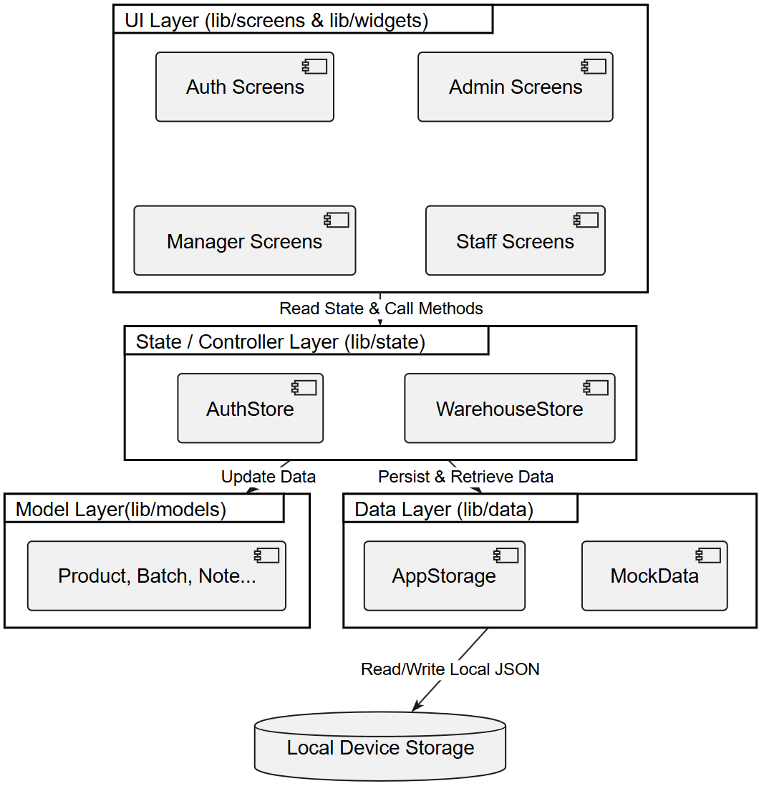

1.2 Package Diagram


Package | Responsibility
lib/models | Entity classes and enums (UserRole, DocumentStatus, DamageType) with toJson/fromJson
lib/state | AuthStore and WarehouseStore (ChangeNotifier) – business logic and application state
lib/data | AppStorage (SharedPreferences persistence) and MockData (first-run seed data)
lib/screens/auth | Login screen and authentication gate routing by role
lib/screens/admin | Admin dashboard, user / product / supplier management
lib/screens/staff | Staff home, document creation forms and lists, stock view, QR scan
lib/screens/manager | Manager home, approval screens per document type, catalogs, reports, audit log
lib/widgets | Reusable UI: status chips/badges, stat cards, reason dialog, empty state, snackbar helper
lib/utils | Formatting helpers (dd/MM/yyyy date formatter)

2. Database Design
Version 1.0 stores each entity collection as a JSON document in SharedPreferences; the logical schema below is designed so that it maps directly onto relational tables when the system migrates to MySQL. Primary keys are UUID strings; fields marked (FK) reference another entity.
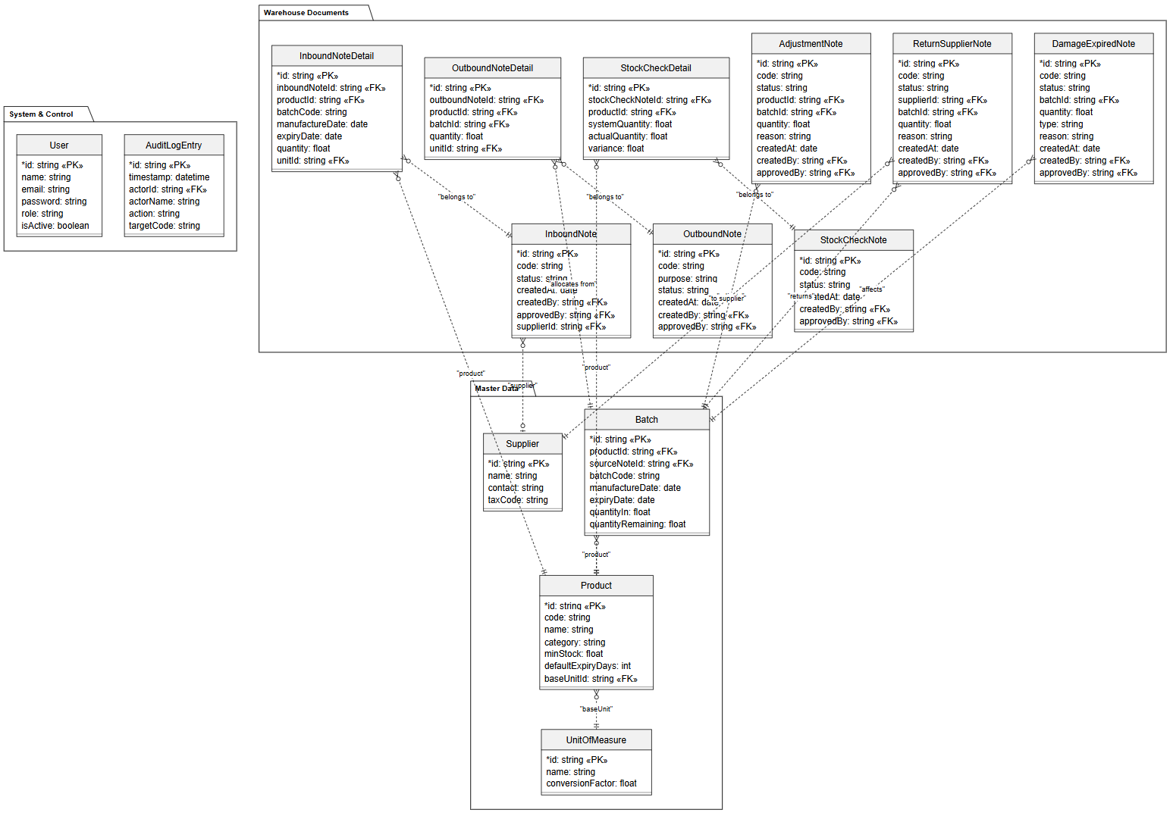

User
Field | Type | Description
id | string (PK) | Unique user id
name | string | Full name
email | string | Login email (unique)
password | string | Password (plain in v1.0 demo; to be hashed on backend migration)
role | enum | admin | warehouseManager | warehouseStaff
isActive | bool | Locked accounts cannot log in

Product
Field | Type | Description
id | string (PK) | Product id
code | string | Unique product code (e.g. GAO-ST25)
name | string | Product name
category | string | Cereals / Nuts / Dried goods…
baseUnitId | string (FK Unit) | Base unit for stock calculation
minStock | double | Minimum stock level for low-stock alerts
defaultExpiryDays | int | Default shelf life used to pre-fill expiry on inbound

UnitOfMeasure
Field | Type | Description
id | string (PK) | Unit id
name | string | kg, Bag (25 kg), Ton, Pack (0.5 kg)…
conversionFactor | double | Factor to convert this unit to the base unit

Supplier
Field | Type | Description
id | string (PK) | Supplier id
name | string | Supplier name
contact | string | Phone / contact info
taxCode | string | Tax code

Batch
Field | Type | Description
id | string (PK) | Batch id
productId | string (FK Product) | Product of the batch
batchCode | string | Human-readable batch code
manufactureDate | date | Manufacture date
expiryDate | date | Expiry date – drives FEFO and alerts
quantityIn | double | Quantity received (base unit)
quantityRemaining | double | Remaining quantity after outbound/return/damage
sourceNoteId | string (FK InboundNote) | Inbound note that created this batch

InboundNote / InboundNoteDetail
Field | Type | Description
id, code | string | Note id and generated document code
createdAt / createdBy | date / string (FK User) | Creation metadata
approvedBy | string (FK User) | Approving manager (nullable)
status | enum | draft | pendingApproval | approved | completed | rejected | cancelled
supplierId | string (FK Supplier) | Supplier of the shipment
details[] | list | Lines: productId, batchCode, manufactureDate, expiryDate, quantity, unitId

OutboundNote / OutboundNoteDetail
Field | Type | Description
id, code, createdAt, createdBy, approvedBy, status | – | Common document metadata as above
purpose | string | Reason / destination of the dispatch
details[] | list | Lines: productId, batchId (FK Batch – FEFO allocation), quantity, unitId

StockCheckNote / AdjustmentNote / ReturnSupplierNote / DamageExpiredNote
Entity | Specific fields (besides common metadata)
StockCheckNote | Lines per product: systemQuantity, actualQuantity, variance
AdjustmentNote | productId/batchId, adjustment quantity (±), reason
ReturnSupplierNote | supplierId, batchId, quantity, reason
DamageExpiredNote | batchId, quantity, type (damaged | expired), reason

AuditLogEntry
Field | Type | Description
id | string (PK) | Log entry id
timestamp | datetime | When the action happened
actorId / actorName | string (FK User) | Who performed the action
action | string | approve / reject / cancel / create / update / delete / lock account...
targetCode | string | Code of the affected document
note | string? | Optional reason

IV. Software Testing Documentation

1. Scope of Testing

1.1 Target of test – features and functions
The target of test is version 1.0 of the WM_Software mobile application. The table below defines which features are tested and which are excluded:
Area | In scope | Out of scope
Authentication & accounts | Login/logout, session restore, role routing, change password, Admin account management (create, lock/unlock) | Forgotten-password recovery by email (requires mail backend, simulated in v1.0)
Master data | CRUD and validation for products, units & conversion factors, suppliers; permission per role | Storage location management (optional feature, not implemented)
Warehouse documents | Create–approve–reject–cancel workflow of all six note types; generated codes; status transitions; locking after approval | —
Batch & FEFO | Batch creation on inbound approval, FEFO allocation order, remaining-quantity validation, batch traceability | —
Alerts & reports | Low-stock / near-expiry / expired alerts, dashboard counters, inbound–outbound–stock and shrinkage figures | Excel/PDF export, push notifications (optional future features)
Control | Audit log entries for approve/reject/cancel; data lock after approval | —
Other | — | QR camera scanning (UI shell only), multi-device data synchronization (local storage in v1.0)

1.2 Non-functional requirements in scope
• Usability: inline Vietnamese validation messages; a new user can complete the inbound flow without training.
• Performance: list rendering and navigation under 1 second with seeded data plus 1,000 generated documents; cold start under 3 seconds.
• Security: role-based access according to the permission matrix; a locked account cannot authenticate.
• Reliability: stock changes only on the approval event; data persisted immediately after every mutation and intact after app restart.
Not tested at NFR level: portability beyond Android (iOS/web builds are compiled but not formally tested) and scalability beyond a single device, because version 1.0 targets one warehouse on local storage.

1.3 Test stages / levels applied
Level | In charge | Inputs / time | Focus | Acceptance criteria
Unit test | Developer of each module | flutter_test suites, run on every commit and in review (weeks 5–9) | WarehouseStore logic: FEFO allocation, stock mutation on approval, unit conversion, alert computation | 100% of unit tests pass on the merge commit
Integration / widget test | Developer + cross reviewer | Widget tests + manual pairwise checks after each feature merge (weeks 6–9) | Form validation, store–UI binding, navigation between list/form/approval screens | No blocking defect; validation messages match the message list
System test | Whole team, cross-testing each other's modules | Test-case sheet (Report5), fresh install with seeded data, 3 rounds before the final checkpoint (week 9–10) | End-to-end business flows across roles, business rules BR-01…BR-11, permission matrix, UI on 2 screen sizes | ≥ 95% pass in round 2; 100% of high-priority cases pass in the final round; no open critical defect
Acceptance test (UAT) | Lecturer / demo audience with the team | Demo scenario script, final build (week 10) | The three demo accounts walk through the full inbound → FEFO outbound → alert → audit-log scenario | Demo scenario completes without failure

1.4 Constraints and assumptions
• Data is stored locally in SharedPreferences, so every system-test round starts from a fresh install to guarantee a known initial state (3 demo accounts, 4 units, sample products, suppliers and batches).
• Passwords are stored in plain text in the v1.0 demo; security testing therefore covers authorization (role access), not cryptographic storage.
• Formal execution is performed on Android devices/emulators; iOS behaviour is assumed equivalent because the codebase is a single Flutter project.
• Time-dependent behaviour (near-expiry and expired alerts) is tested by seeding batches with crafted expiry dates rather than changing the device clock.
• The team has no dedicated tester; each member tests modules written by another member to reduce author bias.

2. Test Strategy

2.1 Testing Types
Type | Objective | Technique | Completion criteria
Functional testing | Verify every use case (UC-01…UC-06 and remaining flows) behaves as specified in the SRS | Black-box, use-case based test design; one positive and at least one negative case per UC | All planned test cases executed, ≥ 95% pass, failures triaged
Validation / boundary testing | Verify form validation: required fields, email format, quantity > 0, quantity ≤ batch remaining, date order (manufacture < expiry) | Boundary value analysis and equivalence partitioning on every input field | All invalid classes rejected with the exact message from the Application Messages List
Business-rule testing | Verify BR-01…BR-11: status workflow, FEFO order, unit conversion, lock after approval, alert thresholds | Scenario testing driving each rule to its trigger condition | No rule violation observed in any scenario
Security (role) testing | Verify the permission matrix for the three roles | Log in with each role; probe every restricted screen and action; verify a locked account is refused | No unauthorized access or action possible
Regression testing | Ensure defect fixes and refactoring do not break existing behaviour | Re-run the full unit-test suite plus a 15-item smoke checklist after every fix batch | All unit tests green; smoke checklist passes
UI testing | Verify layout, empty states, status chips and dialogs render correctly | Manual inspection on a small (5") and large (6.7") screen, light theme | No blocking or high-severity UI defect
Performance testing | Verify responsiveness targets of the NFRs | Stopwatch measurement and Flutter DevTools timeline on seeded + 1,000 generated documents | Navigation < 1 s, cold start < 3 s on the reference device
Acceptance testing | Confirm the product satisfies the course requirements end-to-end | Scripted demo scenario across all three roles | Scenario completes without failure in front of the lecturer

2.2 Test Levels
Level | Test types performed at this level | Description
Unit test | Functional (store logic), regression | Isolated tests of WarehouseStore/AuthStore methods with in-memory storage: FEFO allocation across multiple batches, stock increase/decrease on approval, conversion-factor arithmetic, low-stock and expiry alert computation.
Integration / widget test | Functional, validation/boundary | flutter_test widget tests pumping the real form screens with a test store: submitting invalid forms must surface the correct inline messages; valid submissions must reach the store with converted quantities.
System test | Functional, business rule, security, UI, performance, regression | Manual end-to-end execution of the Report5 test-case sheet on a fresh install, covering cross-role flows (Staff creates → Manager approves → alerts/audit log update).
Acceptance test | Acceptance | Final scripted demonstration of the complete business scenario using the three demo accounts.

2.3 Supporting Tools
Tool | Purpose
flutter_test | Unit and widget test framework bundled with the Flutter SDK
flutter_lints / dart analyze | Static analysis enforced on every commit
Flutter DevTools | Performance timeline and widget-rebuild inspection
Android emulator + physical device | Execution environments for widget and system testing on two screen sizes
GitHub (kimky-hd/WM_Software) | Version control; pull-request review gates merges on green unit tests
Google Sheets / Excel | Report5_Unit Test.xls and Report5_Test Report.xls – test-case management and result recording

3. Test Cases
The full test-case sets are maintained in the course templates: Report5_Unit Test.xls (unit level) and Report5_Test Report.xls (integration, system and acceptance levels). Representative cases of both levels are summarized below.

3.1 Unit test cases (sample)
ID | Method under test | Input / setup | Expected output
UT-01 | WarehouseStore – FEFO allocation | Product with batch A (expiry +10 days, remaining 50) and batch B (expiry +90 days, remaining 100); request 70 | Allocation = [A: 50, B: 20], in that order
UT-02 | WarehouseStore – FEFO allocation (shortage) | Total remaining 60; request 100 | Allocation covers 60 and the 40 shortage is reported
UT-03 | Approve inbound | Pending inbound note with 2 lines | 2 new batches created; quantityRemaining = line quantity; status = Approved; audit-log entry added
UT-04 | Approve outbound | Approved allocation [A: 50, B: 20] | Batch A remaining = 0, batch B remaining = 80; total stock reduced by 70
UT-05 | Unit conversion | Line entered as 2 × Bag (25 kg) | Stock calculation uses 50 kg (base unit)
UT-06 | Low-stock alert | Product minStock = 100; stock falls from 120 to 90 | Product appears in lowStockProducts after the change
UT-07 | Expiry alerts | Batch with expiry date = today − 1 / today + X | Batch listed as expired / near-expiry respectively
UT-08 | Reject note | Manager rejects a pending note with reason | Status = Rejected; reason stored; no batch created; stock unchanged

3.2 System-level test cases (sample)
ID | Function | Test steps (summary) | Expected result
TC-01 | Login – valid | Log in with staff@wm.local / staff123 | Staff home screen is displayed
TC-02 | Login – invalid | Log in with a wrong password | Error message; user stays on Login
TC-03 | Login – locked account | Admin locks an account, then that user logs in | Login is refused
TC-04 | Role routing | Log in with each of the 3 demo accounts | Each role lands on its own home screen
TC-05 | Create inbound – empty lines | Submit an inbound note without any line | Message 'Cần ít nhất 1 dòng sản phẩm'
TC-06 | Create inbound – valid | Add 1 line with valid data and submit | Note created with status Pending approval
TC-07 | Approve inbound | Manager approves the note of TC-06 | New batch created; stock increased; audit log entry written
TC-08 | Reject inbound | Manager rejects with a reason | Status Rejected; reason visible to Staff; stock unchanged
TC-09 | FEFO suggestion | Create an outbound for a product having 2 batches with different expiry dates | The batch with the nearer expiry date is proposed first
TC-10 | Outbound over batch stock | Enter a batch quantity larger than its remaining stock | Inline validation error; submission blocked
TC-11 | Approve outbound | Manager approves a valid outbound note | Batch remaining and total stock decrease correctly
TC-12 | Low-stock alert | Dispatch until stock < minimum level | Low-stock alert appears on Manager dashboard
TC-13 | Lock after approval | Staff attempts to edit an approved note | Editing is not possible; only Manager can cancel (logged)
TC-14 | Stock check variance | Enter an actual quantity different from system quantity | Variance is computed and shown correctly
TC-15 | Damage/expired note | Create and approve a damage note for a batch | Quantity removed from stock; appears in shrinkage report, not sales
TC-16 | Audit log | Perform approve, reject and cancel actions | Each action appears in the audit log with actor and time
TC-17 | Role restriction | Staff tries to open a Manager approval screen | Access is not available to the Staff role
TC-18 | Persistence | Create a pending note, kill and reopen the app | The note and its status are restored from local storage

4. Test Reports

4.1 Result statistics
Summary of the three system-test rounds (sample figures – replace with the team's actual execution results from Report5_Test Report.xls):
Test round | Planned | Executed | Passed | Failed | Pass rate
Round 1 (pre-checkpoint) | 48 | 48 | 39 | 9 | 81.3%
Round 2 (after fixes) | 48 | 48 | 46 | 2 | 95.8%
Round 3 (final regression) | 48 | 48 | 48 | 0 | 100%
Pass rate by feature group in the final round:
Feature group | Cases | Passed | Pass rate
Authentication & accounts | 8 | 8 | 100%
Master data | 7 | 7 | 100%
Inbound / Outbound & FEFO | 14 | 14 | 100%
Stock check / Adjustment / Return / Damage | 10 | 10 | 100%
Alerts, dashboard & audit log | 9 | 9 | 100%

4.2 Defect summary
Severity | Found | Fixed | Open | Typical examples
Critical | 1 | 1 | 0 | Outbound line accepted a quantity larger than the batch's remaining stock, corrupting stock figures
High | 4 | 4 | 0 | Missing required-field validation on inbound lines; expiry date not pre-filled from the product's default shelf life
Medium | 4 | 4 | 0 | Status chip colour mismatch; variance sign displayed incorrectly on stock check
Low | 2 | 2 | 0 | Text overflow of long product names on a 5" screen; inconsistent date format on one report row

4.3 Analysis and conclusion
Defects found in round 1 concentrated in two areas. First, form validation: several required-field checks were missing on document lines, which was fixed by adding validators with the exact messages of the Application Messages List. Second, the outbound flow: the critical defect allowed a dispatched quantity to exceed a batch's remaining stock; the fix added inline validation against the batch remaining quantity (the final commit of the repository), and unit test UT-02/UT-04 plus system case TC-10 were added to guard it in regression.
Round 2 confirmed all functional fixes and left only two minor UI defects on small screens, which were corrected before the final regression. In round 3, all 48 system cases and the full unit-test suite pass, the demo acceptance scenario runs through all three roles without failure, and no defect remains open. The release criterion for version 1.0 is therefore met. For the next version, the team recommends adding automated integration tests for the approval flows and re-executing the performance measurements once the SharedPreferences layer is replaced by the planned Python/MySQL backend.

